Modified Browne Data - Motivation for Modifications

Florian Stijven

2023-09-21

Table of Contents

In this document, we justify the choices to add additional effects of covariates on the outcomes in the original Browne data. We only consider CESD at 6 months as outcome. These additional effects are artificially added to illustrate some ideas that cannot be illustrated with the original data because these (interaction) effects are not present there. We consider the following artificial data set.

* We add a treatment-interaction effect for past major depressive disorder (MDD) (past_MDD) and baseline CESD (cesd) for their effect on CESD at 6 months (cesd2). So, these two baseline covariates are artificially turned into treatment effect modifiers.

We first give some results and plots for the original data where we do an available case analysis to deal with the missing data. This provides a reference to compare the “updated” data sets with. The goal is to change the original data in such a way that the artificial data are still plausible.

# 1 Original data

The outcome regression model for change in CESD is fitted with and without all interaction terms with treatment. These estimated models are summarized next. The values between brackets are the estimated standard errors.

|  | No Interactions | Treatment-Interactions |
| --- | --- | --- |
| (Intercept) | 13.571 (4.956)** | 15.959 (7.452)* |
| groupSertraline and IPT | -0.763 (1.026) | -3.810 (10.036) |
| sexFemale | -1.453 (1.100) | -1.645 (1.630) |
| age | 0.109 (0.051)* | 0.054 (0.078) |
| past_MDDYes | -0.254 (1.018) | -0.190 (1.515) |
| numchild | 0.037 (0.431) | 0.213 (0.666) |
| phealth | -2.643 (0.553)*** | -3.177 (0.843)*** |
| madrs | 0.072 (0.088) | 0.199 (0.130) |
| sas | -5.951 (1.651)*** | -5.448 (2.413)* |
| famfun | -2.474 (0.877)** | -3.216 (1.242)** |
| cesd | 0.716 (0.070)*** | 0.665 (0.104)*** |
| vas | -0.048 (0.034) | -0.045 (0.050) |
| groupSertraline and IPT × sexFemale |  | 0.510 (2.246) |
| groupSertraline and IPT × age |  | 0.115 (0.105) |
| groupSertraline and IPT × past_MDDYes |  | -0.065 (2.076) |
| groupSertraline and IPT × numchild |  | -0.379 (0.885) |
| groupSertraline and IPT × phealth |  | 0.930 (1.124) |
| groupSertraline and IPT × madrs |  | -0.279 (0.179) |
| groupSertraline and IPT × sas |  | -1.128 (3.338) |
| groupSertraline and IPT × famfun |  | 1.601 (1.786) |
| groupSertraline and IPT × cesd |  | 0.087 (0.141) |
| groupSertraline and IPT × vas |  | -0.015 (0.069) |
| R2 | 0.392 | 0.401 |
| R2 Adj. | 0.375 | 0.368 |
| +, p < 0.1; *, p < 0.05; **, p < 0.01; ***, p < 0.001. | | |

We next plot the change score against baseline CESD, stratified by treatment and past MDD. Smooth fits are added to facilitate the interpretation. The gray shaded regions are 95% confidence intervals around the smooth curves.

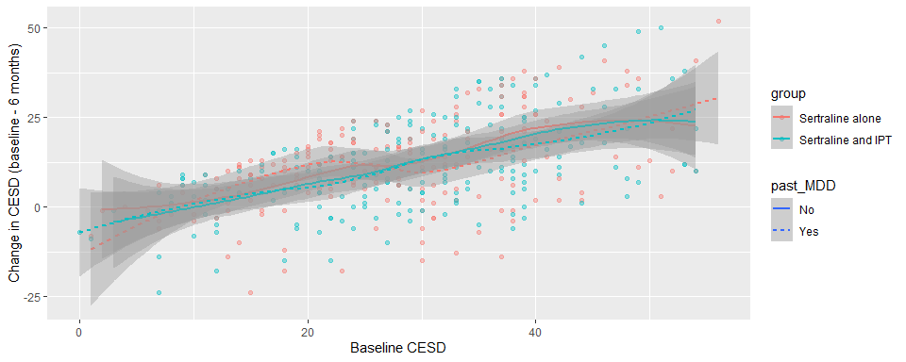

# 2 Update 1

The (first) update involves the introduction of additional treatment effect heterogeneity. The modification of the outcome variable is as follows,

where a tilde indicates the updated value and group corresponds to “Sertraline and IPT”. Patients will thus benefit more from “Sertraline and IPT” (as compared to “Sertraline alone”) if they have a more severe depression at baseline (larger CESD and past MDD).

We next repeat the same regression models and plots as before. There now is a signficant interaction effect for past MDD and baseline CESD. Note also that there is a slight change in R-squared.

|  | No Interactions | Treatment-Interactions |
| --- | --- | --- |
| (Intercept) | 15.211 (5.121)** | 23.959 (7.452)** |
| groupSertraline and IPT | -1.206 (1.060) | -15.810 (10.036) |
| sexFemale | -1.621 (1.137) | -1.645 (1.630) |
| age | 0.120 (0.053)* | 0.054 (0.078) |
| past_MDDYes | -1.378 (1.052) | -4.190 (1.515)** |
| numchild | 0.028 (0.446) | 0.213 (0.666) |
| phealth | -2.554 (0.572)*** | -3.177 (0.843)*** |
| madrs | 0.078 (0.091) | 0.199 (0.130) |
| sas | -6.254 (1.706)*** | -5.448 (2.413)* |
| famfun | -2.253 (0.906)* | -3.216 (1.242)** |
| cesd | 0.668 (0.072)*** | 0.465 (0.104)*** |
| vas | -0.047 (0.035) | -0.045 (0.050) |
| groupSertraline and IPT × sexFemale |  | 0.510 (2.246) |
| groupSertraline and IPT × age |  | 0.115 (0.105) |
| groupSertraline and IPT × past_MDDYes |  | 5.935 (2.076)** |
| groupSertraline and IPT × numchild |  | -0.379 (0.885) |
| groupSertraline and IPT × phealth |  | 0.930 (1.124) |
| groupSertraline and IPT × madrs |  | -0.279 (0.179) |
| groupSertraline and IPT × sas |  | -1.128 (3.338) |
| groupSertraline and IPT × famfun |  | 1.601 (1.786) |
| groupSertraline and IPT × cesd |  | 0.387 (0.141)** |
| groupSertraline and IPT × vas |  | -0.015 (0.069) |
| R2 | 0.347 | 0.398 |
| R2 Adj. | 0.329 | 0.365 |
| +, p < 0.1; *, p < 0.05; **, p < 0.01; ***, p < 0.001. | | |

The following plot is the same as for the original data, but the plot now suggests some degree of treatment effect heterogeneity.

